

**Sukkur Institute of Business Administration University**

Department of Computer Systems Engineering

ELE-111: Workshop Practice, fall 2020

# **Arduino Project Seven Segment Display Countdown**

# **with Buzzer and LED**

Instructor: Engr. Irfan Ali



**List of Equipment**

* Resistors 220 Ohm / 10k Ohm
* LED
* Arduino UNO
* Seven Segment Display
* Buzzer
* Wires
* Bread Board

**Software & Hardware**

Arduino IDE

https://www.arduino.cc/en/software

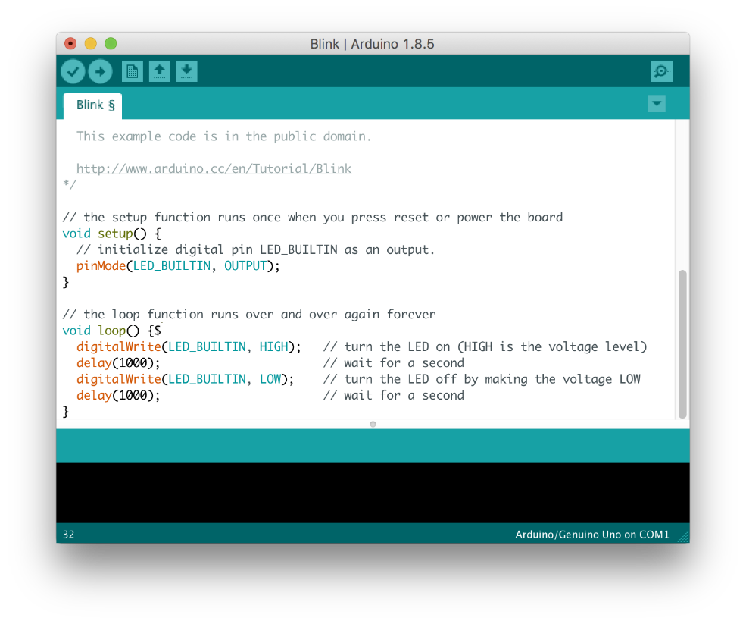

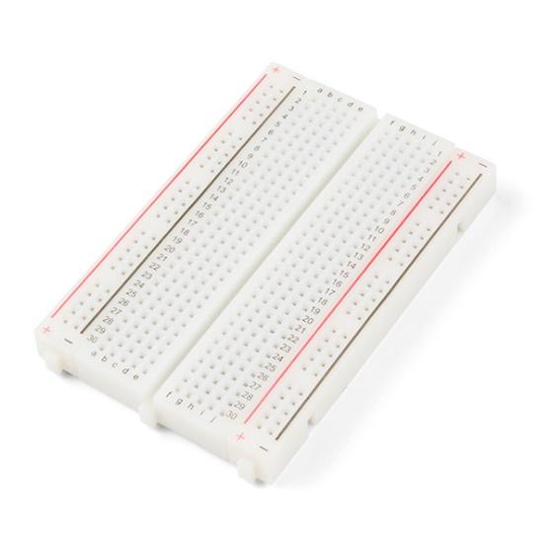

Bread Board

**Abstract**

In this project I will make a countdown seven segment display project that counts

in a sequence from number 9 to 0. To start counting, you need to press the tactile

switch.At the end of counting, it flashes the LED and rings the buzzer for few of

seconds.

**Introduction:**

This project is made by Kashif Mujeeb from BE-I CSE to make a countdown timer with a 7 segment display it counts from 9 to 0. The Arduino Countdown Timer is a fun weekend project for beginners who wants to move on to something slightly more advanced. The timer controls one 7-segment displays which count down from 9 to 0. When the timer reaches 0, the display flashes and a buzzer beeps. This project is ideal for timing any life activity that happens in seconds. We can use 2 or 4 combined 7 seven segment displays for minutes or hours.

Thanks to Sir Irfan Ali Babar for assigning this project.

**Experiment**

Step#1

About Seven Segment Display

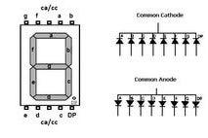

A Seven Segment Display, is a form of electronic display device for displaying decimal numerals that is an alternative to the more complex dot matrix displays. Seven segment displays are widely used in digital clocks, electronic meters, basic calculators, and other electronic devices that display numerical information.

Step#2

**What we will need**

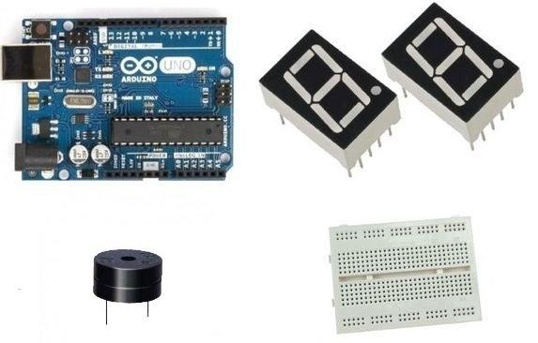

Step#3

## The Circuit

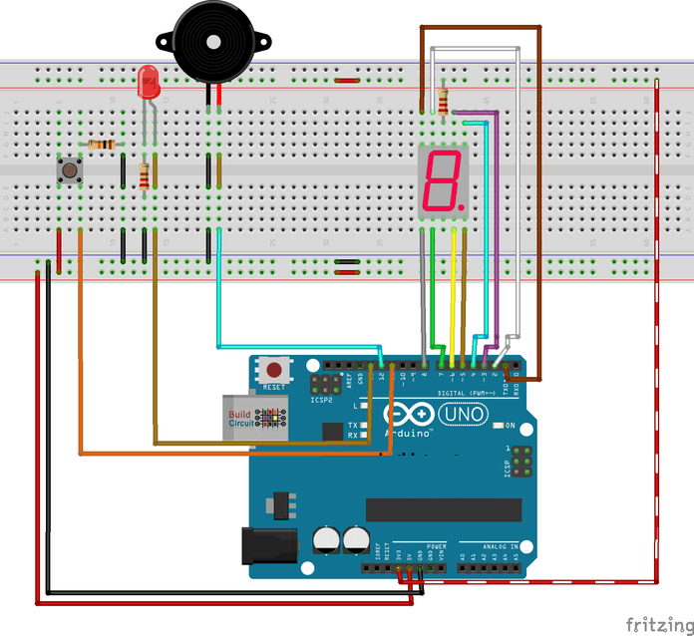

**Results**

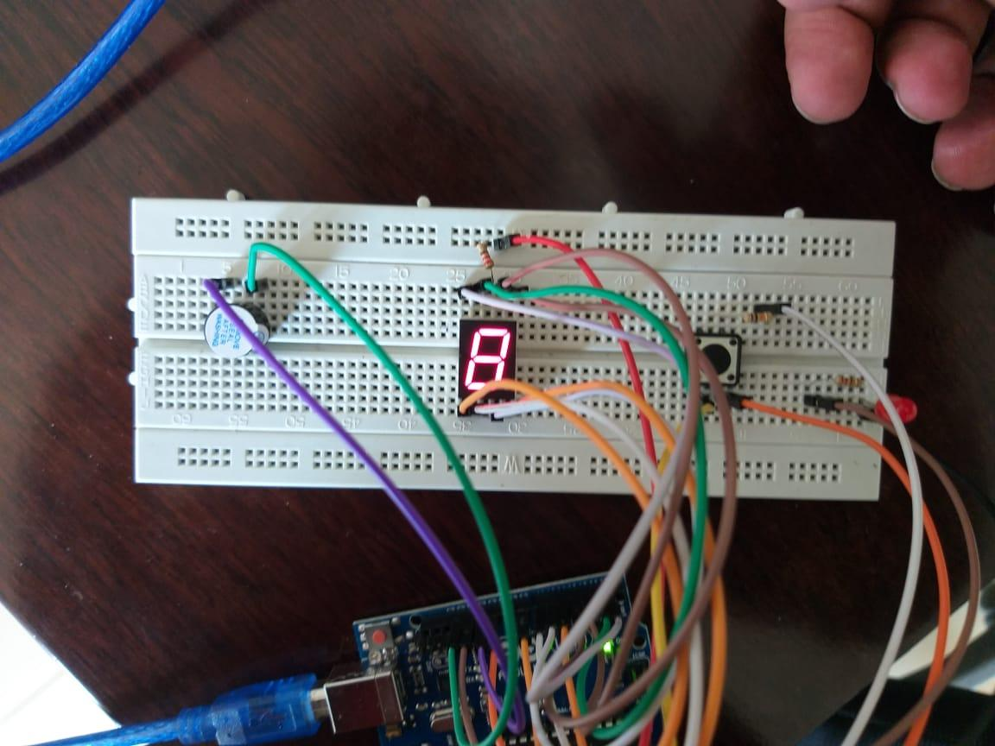

**Conclusions**

A countdown clock can motivate you to do something important faster or quicker as it tells you the

time left to do that thing. For instance, when you see that you only have one hour to complete a

certain task, you will be motivated to try and beat the clock and get the task completed on time

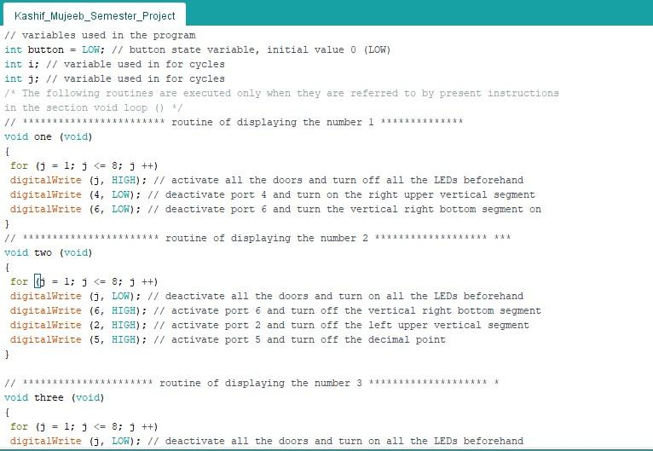

**References**

<https://www.buildcircuit.com/project-arduino-30-arduino-timer-display-1-digit/>

Thanks to Google.